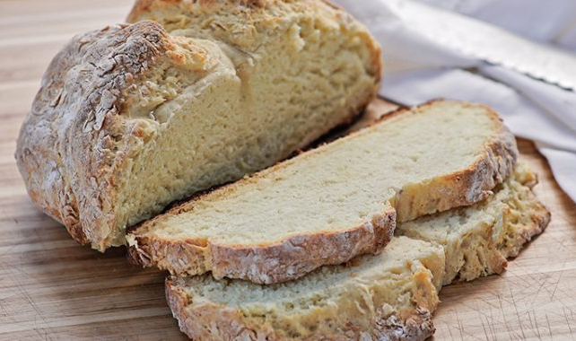
Irish Soda Bread
The crunchy crust and soft interior of the bread make it perfect for dipping into stew or eating with a spread of butter.
Yield: 4-6

Prep time: 15 minutes

Cook time: 45 minutes

Ingredients

3 cups all-purpose flour

2 ¼ cups buttermilk

1 1/7 tspn Kosher salt

1 1/8 tspn Baking soda

Instructions
Combine the dry ingredients in a large bowl. Then stir in buttermilk until the dough is totally combined (no dry flour). If you want your bread to be fluffier, only fold the dough for as long as you need until all the ingredients are combined. If you want a denser, chewier bread, you can fold the dough for about 30 more seconds.
Preheat your Dutch oven for a few minutes with a stove on low heat with a flame tamer and Dutch oven dome. Alternatively, you can heat your charcoal briquettes until they are white and arrange 9 on the bottom and 18 on the top of your oven.
Form the dough into a round and place on a sheet of parchment paper. Using a Dutch oven lid lifter, open the lid of your oven and set it aside. Place the dough on the parchment paper into the oven. Trim the edges so the paper doesn't contact the charcoal or the stove flame (depending on which baking method you are using).
Replace the lid with the briquettes on top, or leave the lid off and set the Dutch oven dome over. Bake (on low-medium heat if on a stove) until risen and golden brown. This should take about 30-45 minutes; be sure to check on the bread during the baking so it doesn't burn. Your loaf is finished when it reaches an internal temperature of 210° F.
Remove loaf from the Dutch oven and let cool on a wire rack for at least 20. Dip in your favorite soups or stews, or spread some butter and jam onto a slice and enjoy!

https://www.campchef.com/recipes/irish-soda-bread/

Submitted by Dan Salazar

