**Dutch Oven Macaroni and Cheese**

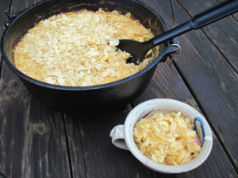

Prep time: 30 Minutes, Cook time: 30 Minutes

**Ingredients:**

1 lb macaroni  
4 tbsp butter  
2 eggs, beaten  
3 cups milk  
2 tbsp flour  
2 tsp dry mustard  
½ tsp salt  
1 medium onion, diced  
6 cups grated cheddar cheese

**Directions:**

Melt half of the butter in a 12" Dutch oven, add in the diced onion and sauté until translucent.  Add in and melt the remaining butter then stir in the flour to make a light roux. Add in the dry mustard and salt.  Mix milk with beaten egg and blend in until thick and bubbly then add in 5 cups of cheese, stirring until melted.  Stir in cooked macaroni noodles then top off with balance of cheese.  Bake at 350º for 25 to 30 minutes. Use 24 charcoal briquettes for the outdoor cooking of this recipe with charcoal as your fuel. Place 15 lit briquettes on top and 9 underneath your Dutch oven. You may need more coals in windy or cold weather.

For variety, try adding in fried bratwurst slices or ham squares.  You can also top your macaroni with crumbled potato chips, corn chips or seasoned bread crumbs before baking. Experiment and have fun, you will want to enjoy this recipe at home and at camp!

Serves 6 to 8 people.

<http://dutchovennet.com/Recipes/Mac_N_Cheese.html>

*Submitted by Dan Salazar*