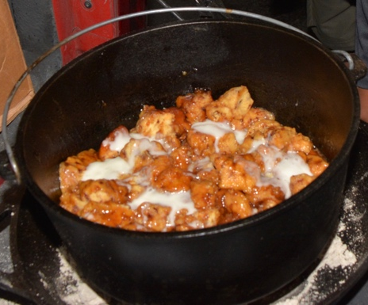
Dutch Oven monkey bread

Ingredients:

2 (12 ounce) containers refrigerated biscuit dough
1 cup (2 standard sticks) butter
2 cups dark brown sugar

Optional:
1 cup chopped pecans
Cinnamon to taste

Preparation:

Cut biscuits into fourths to make triangles
Warm Dutch oven over 25 briquettes or on camp stove
Melt butter and then stir in brown sugar. Mix thoroughly.
Mix in pecans (if used) and coat completely
Stir in dough triangles and coat with brown sugar mixture
Bake for 35 t0 45 minutes using 17 coals on the lid and 8 coals under the oven.
Biscuits are done when they are light golden brown

Variation: Use refrigerated cinnamon rolls instead of regular biscuit dough and drizzle top of monkey bread with sugar glazing from cinnamon roll container prior to serving.

Required equipment:

12-inch camp Dutch oven
Charcoal

